1. **Jatin**:

|  |  |
| --- | --- |
| **JPA** | **Hibernate** |
| Specification (Interfaces, Annotations) | Implementation. |
| Example: We can do mapping with JPA. | But after mapping, the actual work is done by the code provided by the JPA implementation. |

1. 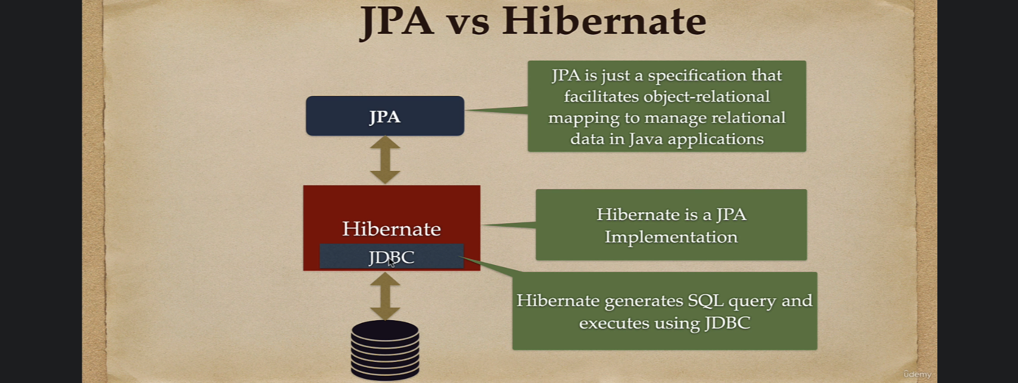
2. A close up of a paper

   Description automatically generated with low confidence